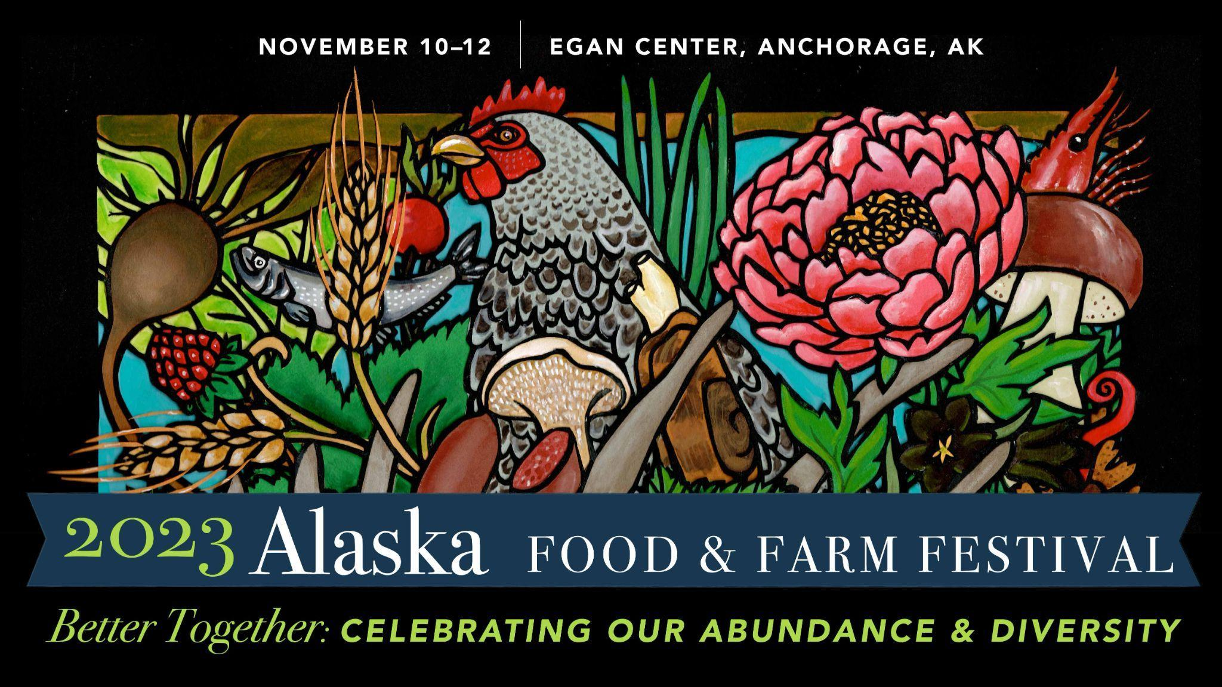

Welcome virtual attendees! We are so excited to have you join us at the 2023 Alaska Food & Farm Festival from Friday November 10th through Sunday November 12th, 2023. Please see the information below regarding your virtual attendance.

EVENT APP AND AGENDA ACCESS
We are using the digital event platform Whova as our event app. Download the Whova app by clicking the link below.

https://whova.com/portal/afpcc_202311/?source=text_link

When registering on the app, you will need to use the same email you used when registering for your event tickets. Whova will give you access to:
- Full event agenda with session descriptions
- Vendor information
- Speaker biographies
- Virtual networking space
- And more!

The Whova app will have the most up to date information so check the app regularly.

For more detailed information on how to use Whova, please click the link below: https://whova.com/pages/whova-app-user-guide/

VIRTUAL EVENT ACCESS

Virtual Event Access
Virtual event access is available through the Whova app. Please see the information below for details on how to access and navigate the Whova Web App. Whova recommends using Google Chrome browser for the web portal.

- Get the web portal link for your event from the event organizer and open the page.
- Click “Sign up here” if you don’t have an account yet, and fill in your email and password.
  - To automatically log in to your event, please make sure to use the email you used when registering for the event. Otherwise you need to input the event invitation code.
  - Note that if you are not using the registered email, you will be prompted to enter the event invitation code. Please request the code from your event organizers.
- The app will automatically take you to the event main page.
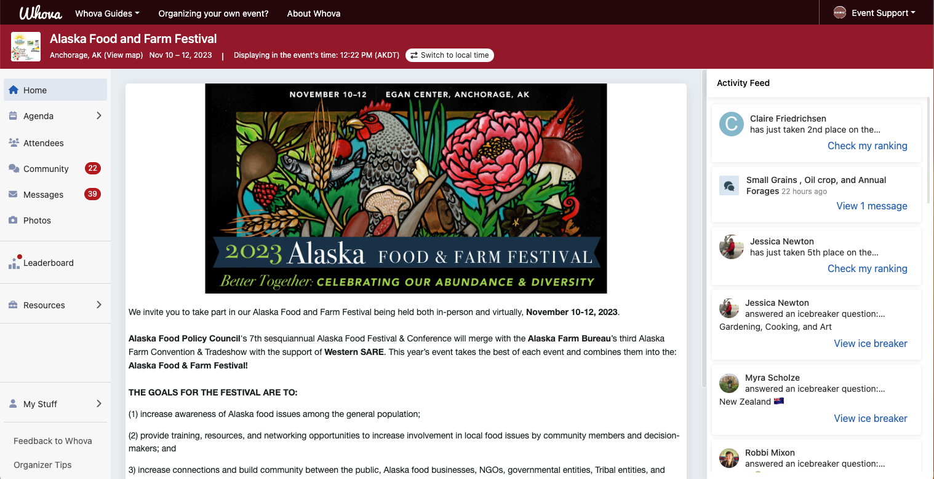
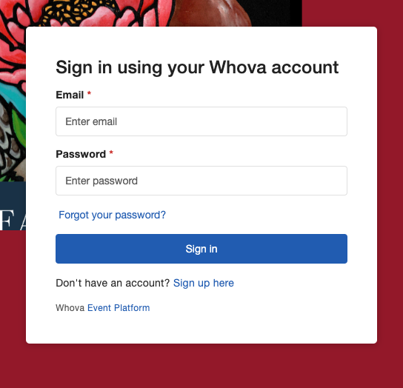

→

View Agenda and Plan Your Schedule
- Find the Agenda tab on the side of the screen. You should see a list of sessions for that day.
- You can move through different days by selecting the date you want to view on the calendar at the top of the agenda.
- Browse or search for sessions on the top bar.
- Once you find the session you want to access, tap on it.
- If the session is live, it will begin playing immediately upon entering. Otherwise, a message will indicate the scheduled start time.
- If the session hasn’t occurred yet, you can click Add to My Agenda to put the session on your own personal agenda and set a reminder.

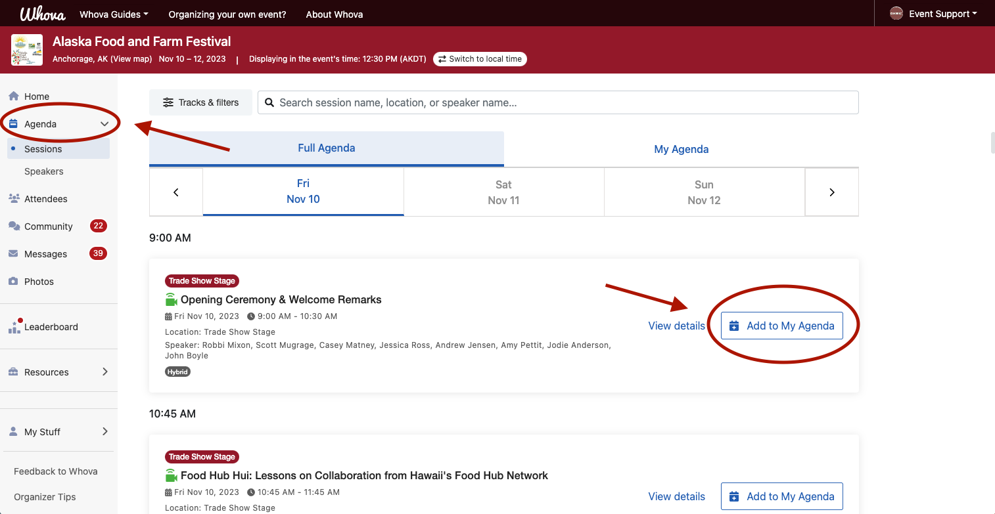

Access Live Stream and Session Videos
**We suggest you use the Chrome browser to join the session streaming. Some streaming software may have compatibility issues with other browsers.

- From the agenda list, click the session you want to watch the stream or video. There is a green camera icon for the sessions with streaming or video.
- If the streaming screen directly shows up, click “Proceed” to start watching the stream. Otherwise click “View livestream” button to open a separate streaming page to watch.

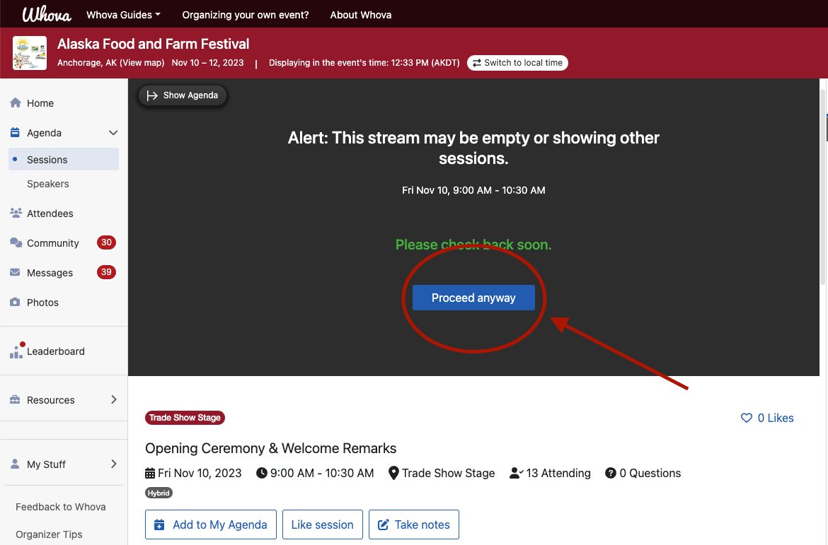

Use Session Q&A
- Option 1: You can access three tabs on the right hand side of the virtual session: Session Q&A, Chat, and Community. You can submit questions for the presenter through Session Q&A, participate in ongoing discussions with the other attendees viewing the session through Chat, and browse the Community Board function through Community.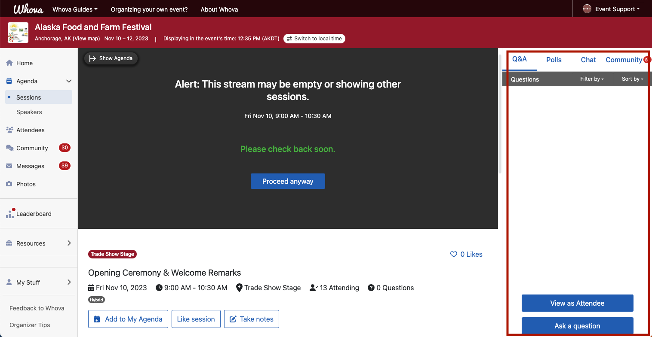

- Option 2: You can use this function through the “Session Q&A” tab on the left hand sidebar underneath Resources. 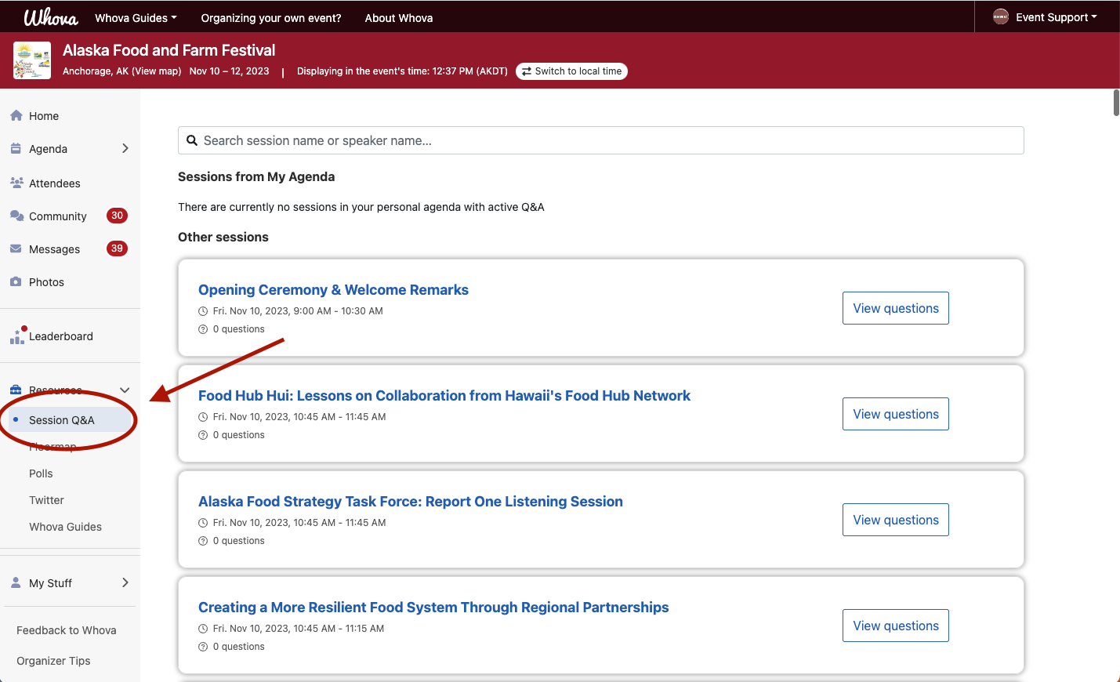

See Who Is Attending the Event
- Click the “Attendees” tab on the left side of the screen under Main Navigation.
- At the top of the page, you can search attendees by keywords such as company name or title.
- To start a conversation, click Send Message to begin a chat.
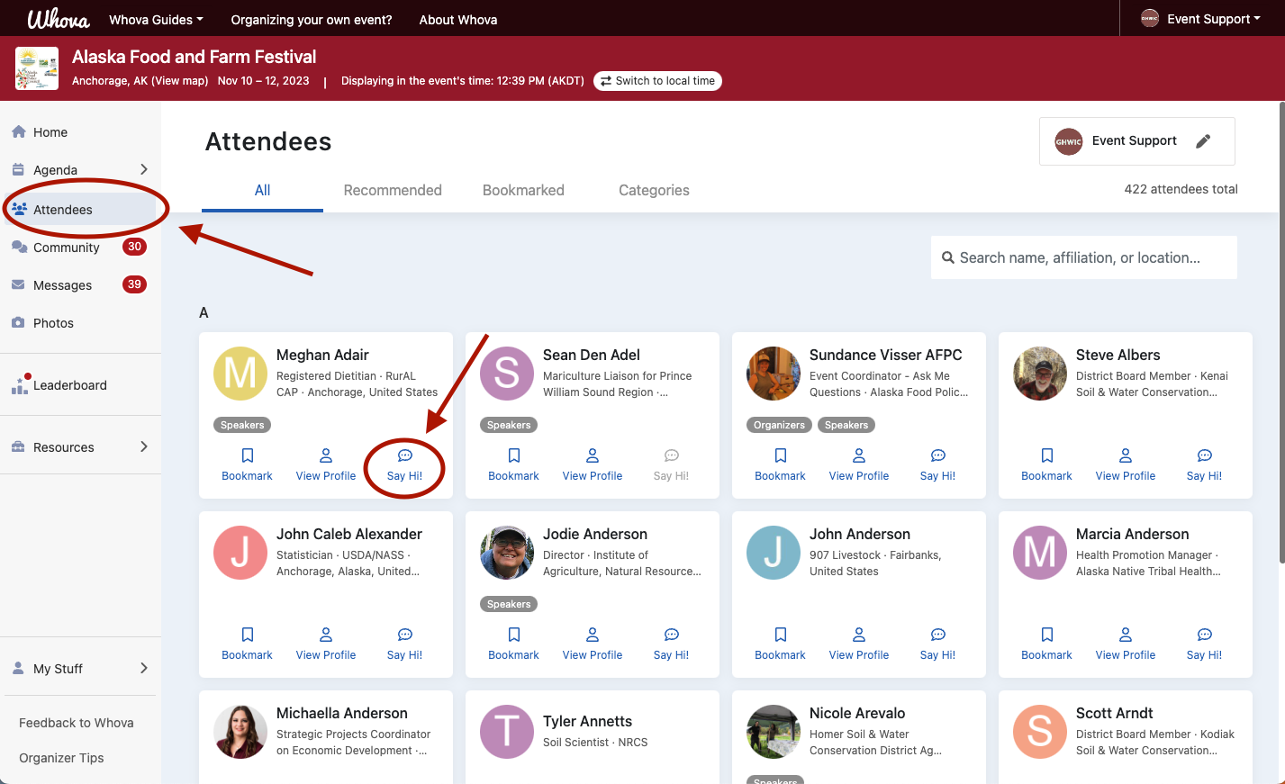

Join Discussion on the Community Board
- Click the Community tab on the side menu to the left of the screen
- Create a new conversation topic, or use existing topics like “Meet-ups.”
- Click Follow directly next to the topics on the Community Board that you want to stay up to date with. To find the topics you’re following, choose between three tabs near the top of the topics list section: All Topics, Followed, and New Topics.
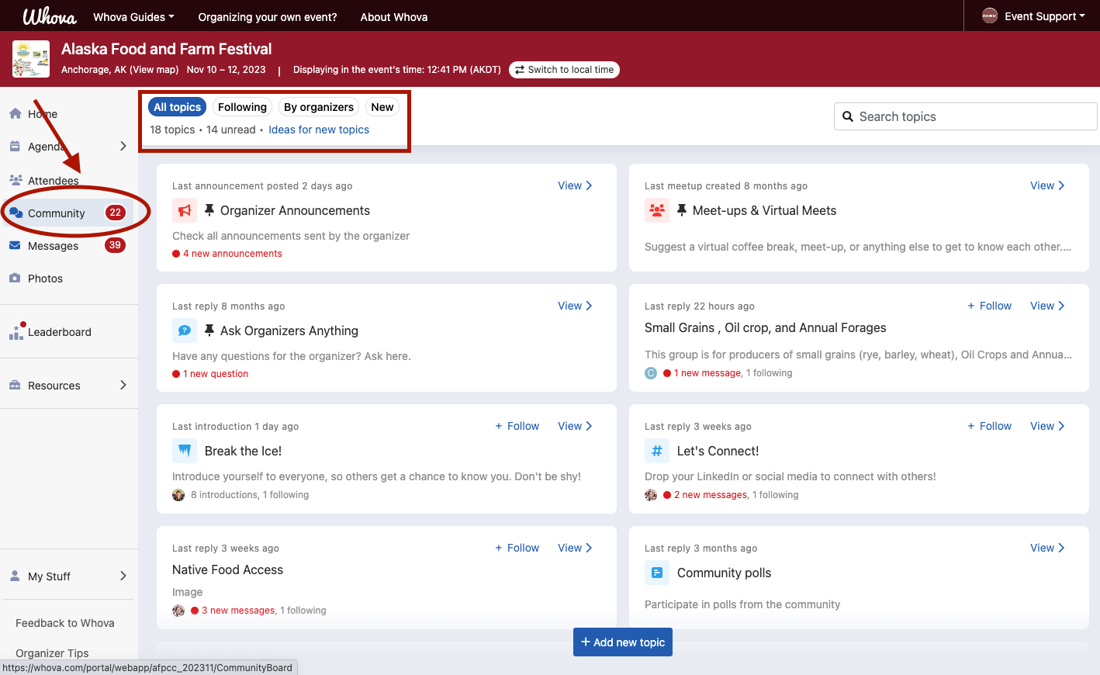

Zoom Overview
The conference app Whova uses Zoom for the hybrid presentations and virtual attendees.

Before joining the conference via Zoom on a computer or mobile device, you can download the Zoom app from the Download Center. Otherwise, you will be prompted to download and install Zoom when you click the Zoom link to join the event. The Zoom Help Center contains step-by-step instructions to help you sign on using various devices. The help center has a number of articles available on the features of Zoom.

The easiest way to join the conference is to download the Zoom app on your preferred “screen view” device. The optimal “screen view” of the presentations will be displayed on a computer monitor. Open up this email and click on the Zoom link. This will bring you to the waiting room where you will be admitted by the host. An alternative way to join the Conference is to open a browser (e.g. Chrome) and go to join.zoom.us and enter the appropriate meeting ID when prompted to do so.

If you are a Zoom veteran and have previously installed the Zoom app, we recommend that you download the most recent and updated version here. This will allow you to utilize the updated features on Zoom and will provide the best viewing experience. For optimal viewing of the presentations, we recommend using Speaker View.

EVENT WEBSITE
For more information about the 2023 Alaska Food and Farm Festival, please visit our website at: https://www.akfoodpolicycouncil.org/2023-festival-conference

ADDITIONAL QUESTIONS
If you have any questions regarding Whova, please email Meghan Hargis at meghan@alaskafarmersmarkets.org with the subject line: “Alaska Food and Farm Festival 2023 Whova Question”

For general event questions, please contact Sundance Visser at 907-756-3930.

We look forward to seeing you at the event!

The AK Food and Farm Festival Planning Team

