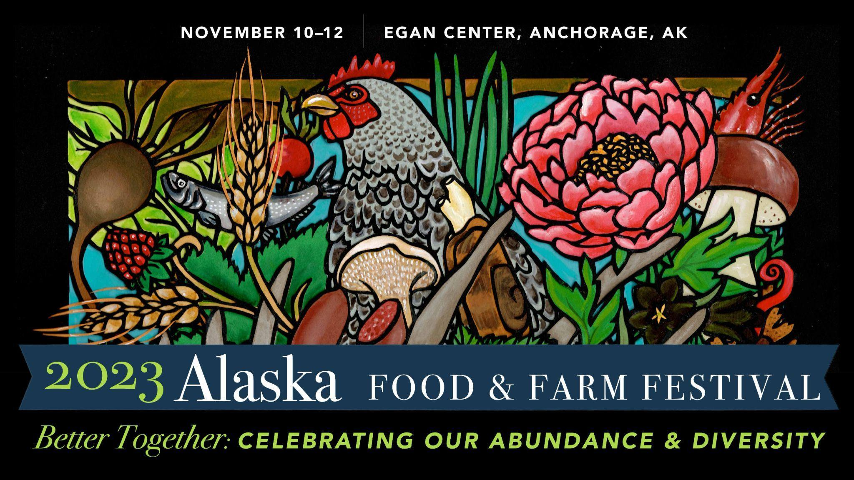

We are so excited to have you join us at the 2023 Alaska Food & Farm Festival from Friday November 10th through Sunday November 12th, 2023 in downtown Anchorage. Please see below for detailed information about accessing and using the event platform Whova.

WHOVA: THE PLATFORM AND EVENT APP
We are using the digital event platform Whova as our event app. Download the Whova app by clicking the link below.

https://whova.com/portal/afpcc_202311/?source=text_link

ACCESSING WHOVA
After you have downloaded Whova, you can access your account by using the same email address you used when registering for your event tickets.
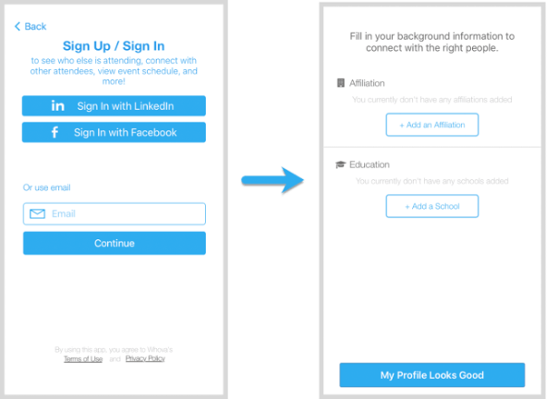

We recommend you edit your profile after logging in! Other attendees will use this to network with you, so it can be helpful to add a picture, your professional affiliation, and more!

VIEW THE AGENDA AND PLAN YOUR SCHEDULE
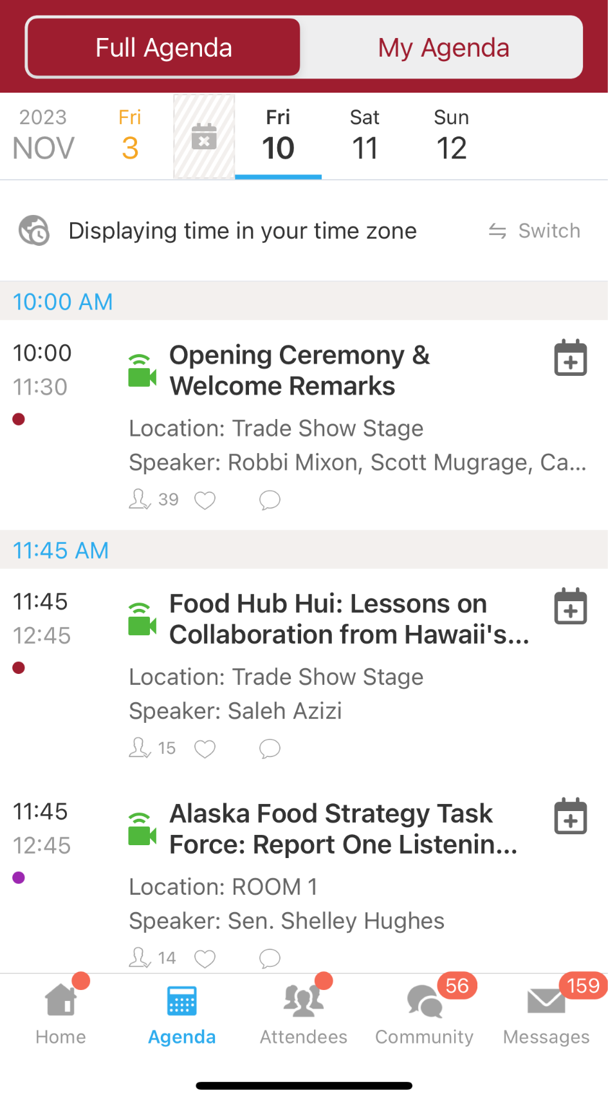

On the bottom of your screen, there is a navigation bar. Here, you will see an “agenda” button. If you click on this agenda button, you will be able to see all Sessions and all Speakers that will be included in the event!

If you click on a specific session, you will be able to see all of the details for that specific session. You can click the “Add to My Agenda” button to add the session to your individual agenda - this way, you can pre-plan all of the sessions you want to attend!
If a session is being live streamed, you can also access that live stream here.

NETWORK WITH OTHER ATTENDEES
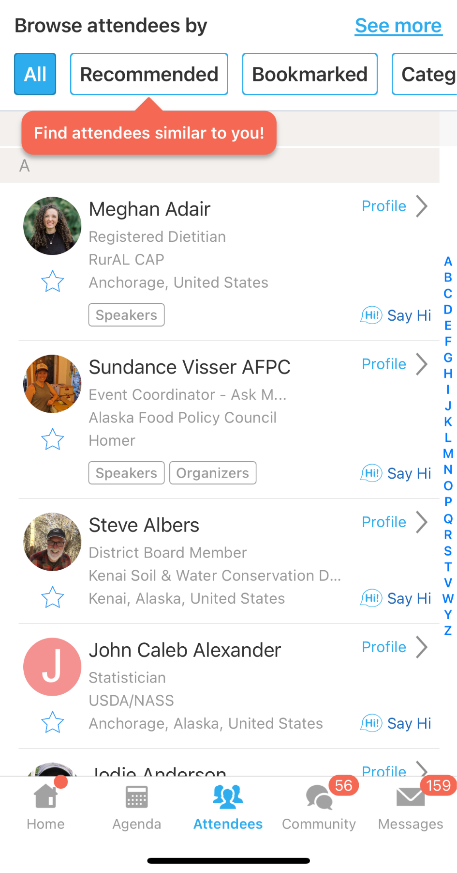
Next to the agenda button is the Attendees button! By clicking here, you can find and network with other event attendees.

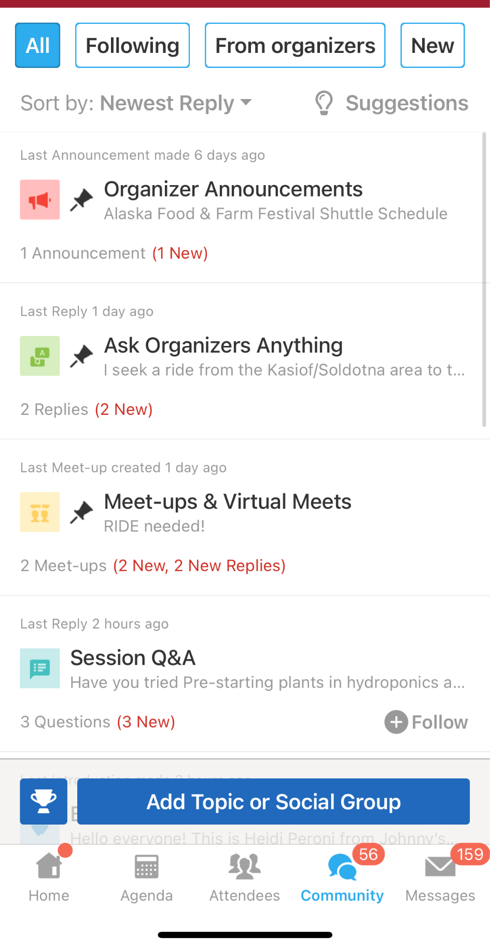

You can engage in icebreaker activities, join conversations about specific sessions, and reach out to the event organizers through the Community button - right next door to where you find Attendees!

